PIZZA SALES SQL QUERIES
A. KPI’s
1. Total Revenue:
SELECT SUM(total_price) AS Total_Revenue FROM pizza_sales;
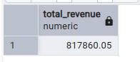
2. Average Order Value
SELECT CAST(CAST(SUM(total_price) AS DECIMAL(10,2)) /
CAST(COUNT(DISTINCT order_id) AS DECIMAL(10,2))
AS DECIMAL(10,2)) AS Avg_Pizzas_per_order
FROM pizza_sales;
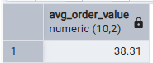
3. Total Pizzas Sold
SELECT SUM(quantity) AS Total_pizza_sold FROM pizza_sales;
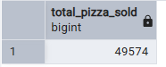
4. Total Orders
SELECT COUNT(DISTINCT order_id) AS Total_Orders FROM pizza_sales;
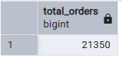
5. Average Pizzas Per Order
SELECT CAST(CAST(SUM(quantity) AS DECIMAL(10,2)) /
CAST(COUNT(DISTINCT order_id) AS DECIMAL(10,2)) AS DECIMAL(10,2))
AS Avg_Pizzas_per_order
FROM pizza_sales;
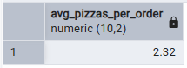

B. Visuals
1. Daily Trend for Total Orders
SELECT TO_CHAR( Order_date, 'DAY') AS order_day, COUNT(DISTINCT order_id) AS total_orders
FROM pizza_sales
GROUP BY TO_CHAR( Order_date, 'DAY');
Output:
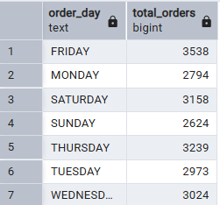
2. Monthly Trend for Orders
SELECT TO_CHAR( Order_date, 'MONTH') AS order_day,
COUNT(DISTINCT order_id) AS total_orders
FROM pizza_sales
GROUP BY TO_CHAR( Order_date, 'MONTH');
Output
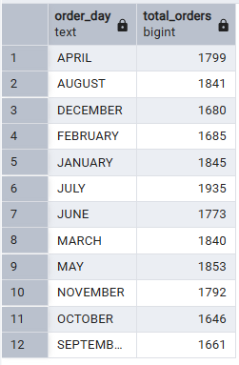
3. % of Sales by Pizza Category
SELECT pizza_category,
CAST(SUM(total_price) AS DECIMAL(10,2)) as total_revenue,
CAST(SUM(total_price) * 100 / (SELECT SUM(total_price) from pizza_sales) AS DECIMAL(10,2)) AS PCT
FROM pizza_sales
GROUP BY pizza_category;
Output
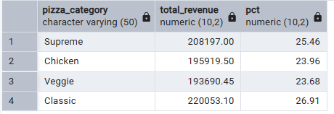
4. % of Sales by Pizza Size
SELECT pizza_size,
CAST(SUM(total_price) AS DECIMAL(10,2)) as total_revenue,
CAST(SUM(total_price) * 100 / (SELECT SUM(total_price) from pizza_sales) AS DECIMAL(10,2)) AS PCT FROM pizza_sales
GROUP BY pizza_size
ORDER BY pizza_size;
Output
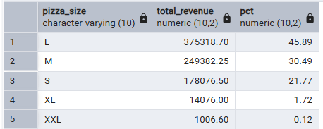
5. Total Pizzas Sold by Pizza Category
SELECT pizza_category, SUM(quantity) as Total_Quantity_Sold
FROM pizza_sales
WHERE EXTRACT(MONTH FROM order_date) = 1
GROUP BY pizza_category
ORDER BY Total_Quantity_Sold DESC;
Output
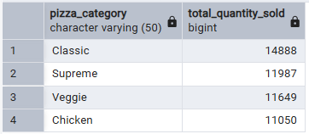
6. Top 5 Pizzas by Revenue
SELECT pizza_name, SUM(total_price) AS Total_Revenue
FROM pizza_sales
GROUP BY pizza_name
ORDER BY Total_Revenue DESC
LIMIT 5;
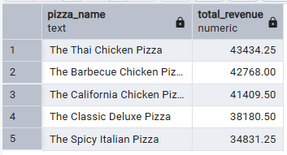
7. Bottom 5 Pizzas by Revenue
SELECT pizza_name, SUM(total_price) AS Total_Revenue
FROM pizza_sales
GROUP BY pizza_name
ORDER BY Total_Revenue ASC;
LIMIT 5;
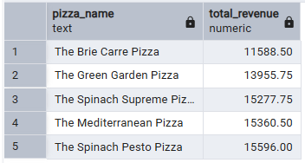
8. Top 5 Pizzas by Quantity
SELECT pizza_name, SUM(quantity) AS Total_Pizza_Sold
FROM pizza_sales
GROUP BY pizza_name
ORDER BY Total_Pizza_Sold DESC
LIMIT 5;
Output
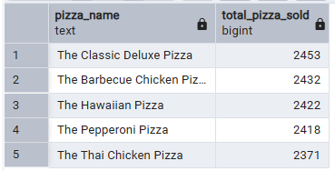
9. Bottom 5 Pizzas by Quantity
SELECT pizza_name, SUM(quantity) AS Total_Pizza_Sold
FROM pizza_sales
GROUP BY pizza_name
ORDER BY Total_Pizza_Sold ASC
LIMIT 5;
Output
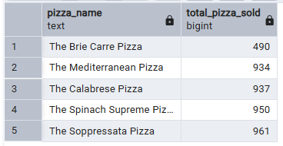
10. Top 5 Pizzas by Total Orders
SELECT pizza_name, COUNT(DISTINCT order_id) AS Total_Orders
FROM pizza_sales
GROUP BY pizza_name
ORDER BY Total_Orders DESC
LIMIT 5;

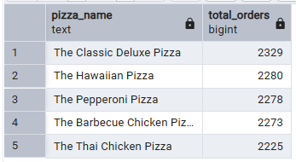
11. Bottom 5 Pizzas by Total Orders
SELECT pizza_name, COUNT(DISTINCT order_id) AS Total_Orders
FROM pizza_sales
GROUP BY pizza_name
ORDER BY Total_Orders ASC
Limit 5;
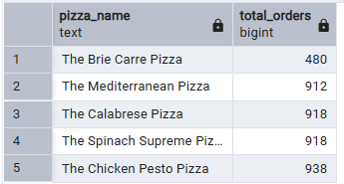
NOTE
If you want to apply the pizza_category or pizza_size filters to the above queries you can use WHERE clause. Follow some of below examples
SELECT pizza_name, COUNT(DISTINCT order_id) AS Total_Orders
FROM pizza_sales
WHERE pizza_category = 'Classic'
GROUP BY pizza_name
ORDER BY Total_Orders ASC
LIMIT 5;

